Scenario:

One of Visas legacy back office system is undergoing a UI revamp and the product team has proposed a new layout adhering to single page application standard. The main users of this global system are financial institutions and internal Visa users. The layout should be responsive, desktop first and should be in alignment to Visa design guidelines (see theme colors at the end of the question).

Case Detail View

The main entity of this system is called Case and you will be designing a “Case detail View”. A case involve 4 actors: Issuer (the bank that issued your card), Acquirer (merchant’s bank), Card holder and Merchant.

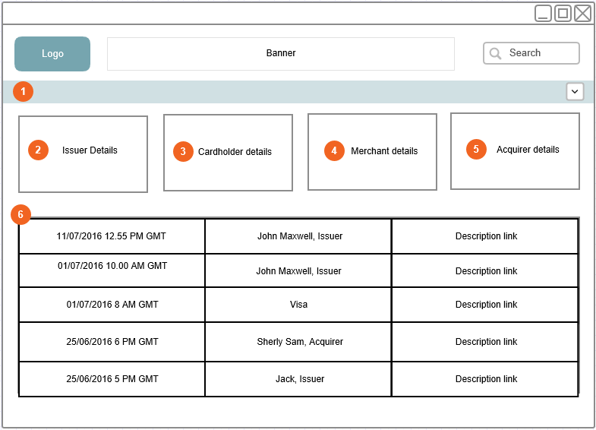

**1** - A collapsible row of actor details. By default this row will be expanded. The handle at the right of this row will toggle the view. Each actor block will have some kind of tabular information

You can use following details to fill in each block:

**2**- Issuer: Name, Address (3 to 4 lines)

**3** - Cardholder: Name, Card Number, Address (3 to 4 lines)

**4** - Merchant: Name, Address (3 to 4 lines)

**5** - Acquirer: Name, Address (3 to 4 lines)

**6**. This area is called the “Case Detail” grid view. A case can have 100s of events. Here events are presented in chronological order. This grid view should be self-contained and should have a scrollbar in case of overflow. Each item of the grid will have a time stamp, actor/user details and a link that can take you to the next view “Event Detail”.

Event Detail View

Once the user is in detail view, screen will reorganize itself to give more real estate for the user to work. The actor detail view (1) will be collapsed and the grid will turn into a timeline view (2) at the left side of the screen

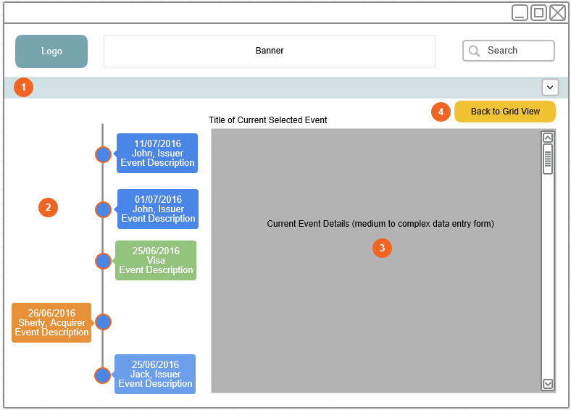

**1 -** The collapsed actor detail view.

**2 –** Event timeline. Current selected event should be shown in a different color (or highlighted). Issuer/Acquirer/Visa events should use be easily traceable. User can click any of the timeline bubble to move to that event details.

**3 –** Event detail view. A medium to complex form will appear here with action buttons at the bottom. In case of a long form, a vertical scrollbar should appear. **For the exercise, keep a lengthy dummy form in this view.** Once an action has been taken in the form (e.g.: Save), user should be taken to the initial grid view.

**4 –** At any point a user can switch back to the initial view by clicking the button (Back to Grid View).

Theme colors

visa-primary-white : #ffffff;

visa-primary-blue : #1a1f71;

visa-primary-gold:#f7b600;

visa-orange : #ef8400;

visa-yellow: #ffd700;

visa-chart-blue : #0065ea;

visa-primary-gray : #75787b;

visa-text-gray : #5c5c5c;

visa-custom-red : #DC553E;

visa-custom-green : #0c7d34;